**MUM BLOG**

Senior project

By

**Solomon Meles – 108429**

In partial fulfillment of the requirement for the award of BS in Computer Science degree.

Advisor: Professor Obinna Kalu

November 2018 CS @ MUM

Table of Content

# Project description

#### vision………………………………………………………………………………………………………………………………………………….........3 1.1 introduction………………………………………………………………………………………………………………………………………….3 1.2 positioning……………………………………………………………………………………………………………………………………………4 1.3 problem Statement……………………………………………………………………………………………………………………..…......4 1.4 product position statement **1.4.1** stakeholders Description………………………………………………………………………………………………………………..4

##### 1.5 stakeholder summary…………………………………………………………………………………………………………………………..4

#### 1.6 product overview………………………………………………………………………………………………………………………………..5

1.6.1 product perspective…………………………………………………………………………………………………………………...5

1.6.2 Assumptions and dependencies ……………………………………………………………………………………………....6

##### 1.7 Needs and Features …………………………………………………………………………………………………………………………….6

1.8 User Environment………………………………………………………………………………………………………………………………..6  
1.9 Alternatives and Competition………………………………………………………………………………………………………………6  
1.10 Other Product Requirements……………………………………………………………………………………………………………..6

# Use Case Specification 2.1 Post by User …………………………………………………………………………………………………………………………7 2.2 Comment by User…………………………………………………………………………………………………………………8 2.3 Edit by User…………………………………………………………………………………………………………………………..9 2.4 Approve by Admin………………………………………………………………………………………………………………10 2.5 Delete by Admin………………………………………………………………………………………………………………….11 2.6 Registration of user to the system……………………………………………………………………………………….12

# USER CASE DIAGRAM…………………………………………………………………………………………………13

# USER INTERFACE…………………………………………………………………………………………………14-16

# OVERVIEW OF DESIGN

SPRINGBOOT……………………………………………………………………………………………………………………………….17

# CONCLUSION *list of technologies and materials used for this project…………………………………………………..18* GLOSSARY………………………………………………………………………………………………………………………………….19

1. **Introduction**

Mum have a Mobile application which can be used to post different kind of things which can be shown as a news feed. But having a log where a student or faculty can post something and get comments as well. Posts can be even a problem u face while doing your assignment and people can comment on your problem and even answer to your question or problem.

So, having this application is very useful and can be a solution to a lot of student long night homework and arranging different events.

Basically, a student or faculty can post an article and people can give their feedback using the comment under the article. For the users to comment or Add a new post they have to login which is a security and the rest is open for any users to read and article.

* 1. **Positioning**

**problem statement**

|  |  |
| --- | --- |
| The problem of | *Having a website where student can seek for answer and previous students experience* |
| Affects | *administrators, faculty, and students* |
| the impact of which is | *Student now can’t find website to make research on their specific problems.* |
| a successful solution would be | *Creating a blog website where the mum residence can write an article and get a feedback for their article/ options or questions* |

**1.4 Product Position statement**

|  |  |
| --- | --- |
| For | *Mum faculty, mum students, mum administration, anyone interested in TM* |
| Who | Article write and answer for a Questions. |
| The MUMBLOG | *Is a Website category* |
| That | *It make communication easier in a certain community and it can be managed by admin.* |
| Unlike | *Better than MUM Mobile App* |
| Our product | *It’s Free of any charge and can be used by anyone* |

* + 1. Stakeholder Descriptions

**Stake**

**1.5 Stakeholder Summary**

|  |  |  |
| --- | --- | --- |
| Name | Description | Responsibilities |
| Admin | **Approve for Post/ delete post/ answer to report.** | **Admin is responsible in setting up and initial data and system managing.** |
| Faculties/Students/TM interested People | **Add a post, edit a post Write comment** | **These Users (System Users) are responsible for register and participate in the blog.** |
| Developers | **Develop the system from scratch and deploy** | **Have the responsibility of deploying, debugging, maintenance and mainly Develop the system** |
| Testers | **Test the System** | **Are responsible to approve the project completion.** |

**1.6. Product Overview**

**1.6.1 Product Perspective**

This product is totally independent can be used by anyone who’s from the community of the MUM or interested parties. You don’t need any special permission or no requirement to use the Website. Future plane can be to be integrated it to the MUM mobile app or make a separate IOS application. This is based on the survey collected from the users after the initial release.

**1.6.2 Assumptions and Dependencies**

Right now, there is no assumption we can make but, in the future, the IOS can be changed in to Android based on the survey. But since this is a web application no problem with it to run in any OS.

**1.7 Needs and Features**

|  |  |  |  |  |  |  |
| --- | --- | --- | --- | --- | --- | --- |
| *No* | *Problem* | *Need* | | *Priority* | *Features* | *Planned Release* |
| *Schedule Admin* |  |  |  | |  |  |
| *1* | ***The university have few department and student doesn’t have a way they can communicated their problem (Home Work)*** | ***You must have some organized thing to people can communicate*** |  | | ***Admin must approve new posts and review reports*** |  |
| *Schedule User* |  |  |  | |  |  |
| *2* | ***Student need some way they can communicate and ask for help using official MUM website*** | ***How to communicate and ask for help and suggestion to*** |  | | ***All of them can participate in the posts and comments equally and both of them should wait for approval from the admin*** |  |
| *3* | ***Student and faculty can login using any email*** | ***They should be able to view the posts and once of their own*** |  | | ***Users can login to the system with the user name and pass word they choose to use*** |  |

**1.8 User Environment**

This application is developed by a single person. For the time management I’m using Project Management to track my task and activity with respect to the time I must develop and deliver the application. The Application is a standalone project not integrated with any external applications.

**1.9 Alternatives and Competition**

The main advantage this Blog Application have is this blog is a website which means it’s bigger. This blog Website also is mainly focused in solving problems or question that are resided in discussion or homework. Student can upload Question and answer to different problems and faculty can also provide answer to problems or can help by giving suggestions.

**1.10 Other Product Requirements**

MUM Blog have no special required software or hardware just like a normal website application. Users use Google Chrome and Firefox may enjoy better view since these browsers are better in the world of Web programming.

**2.1 use case POST by USER**



**2.2 Use Case Comment USER**



**2.3 Use Case Edit post**



**2.4 Approve by Admin**



**2.5 Delete Post By Admin**



**2.6 Registration by User**



**Chapter 3**   
 🡪 **USER CASE**



**CHAPTER 4**

* **User interface**

**HOME PAGE**

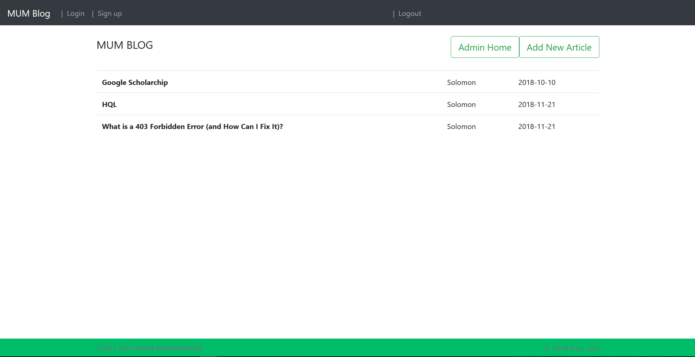

**VIEW POST**

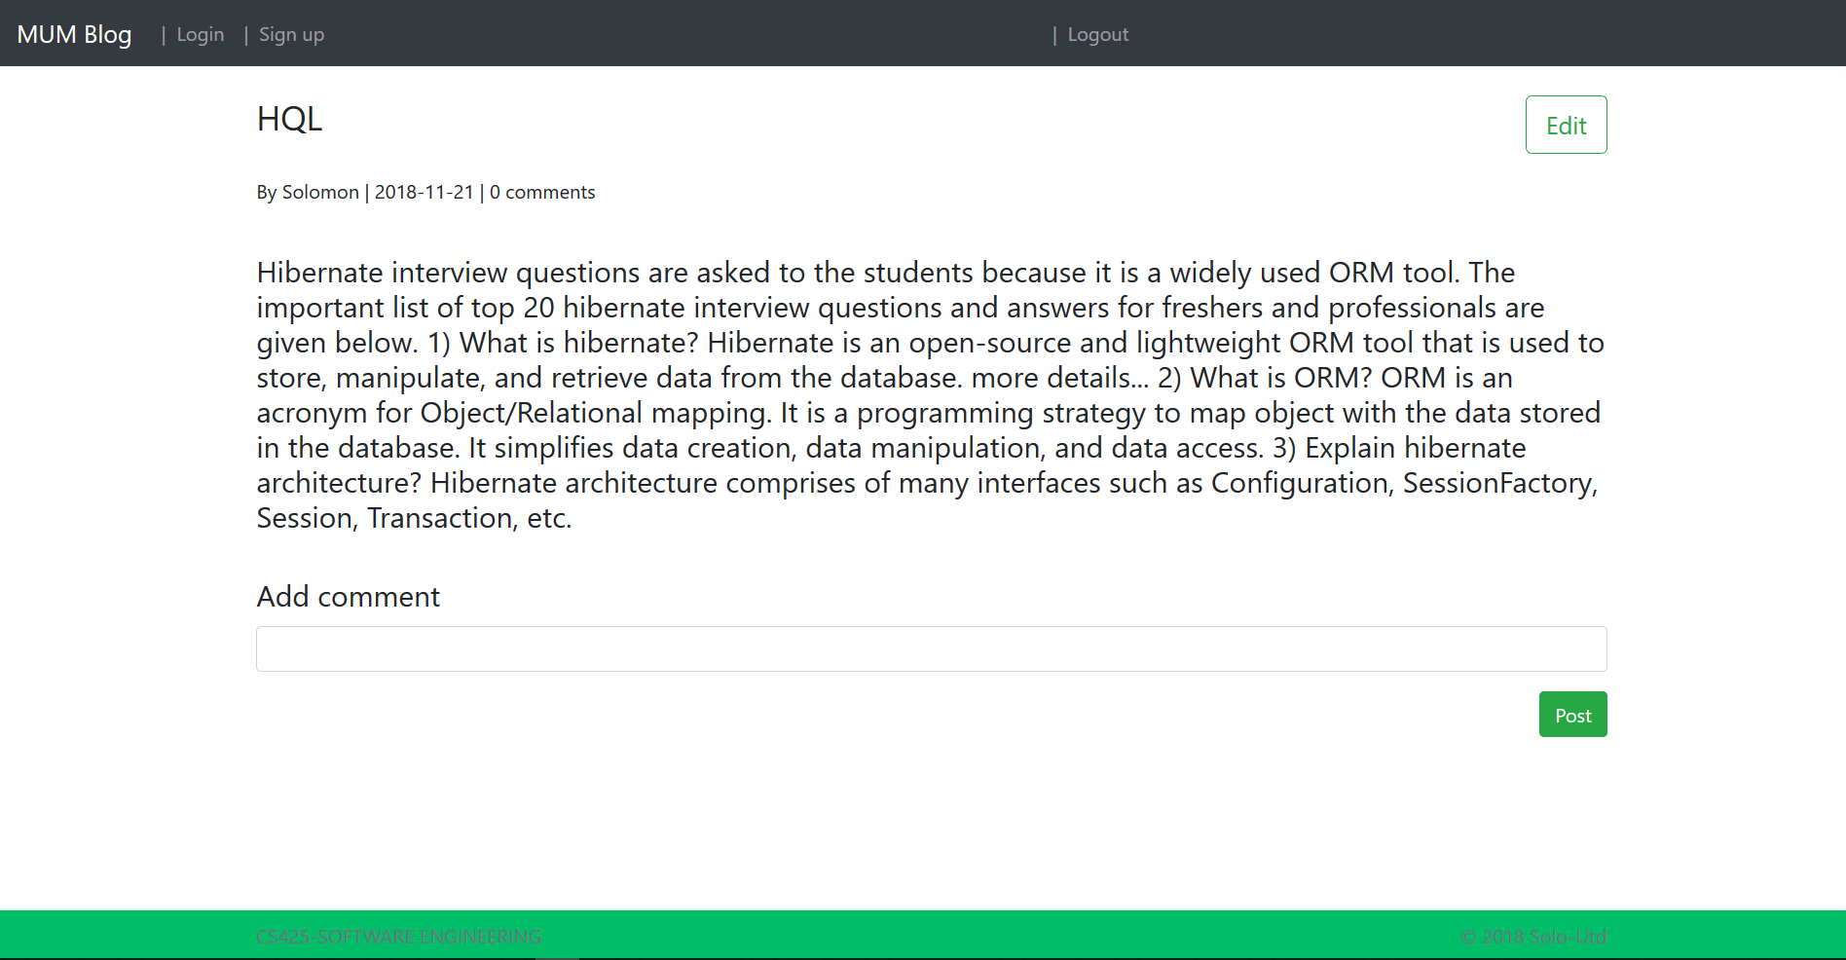

**Add Comment**

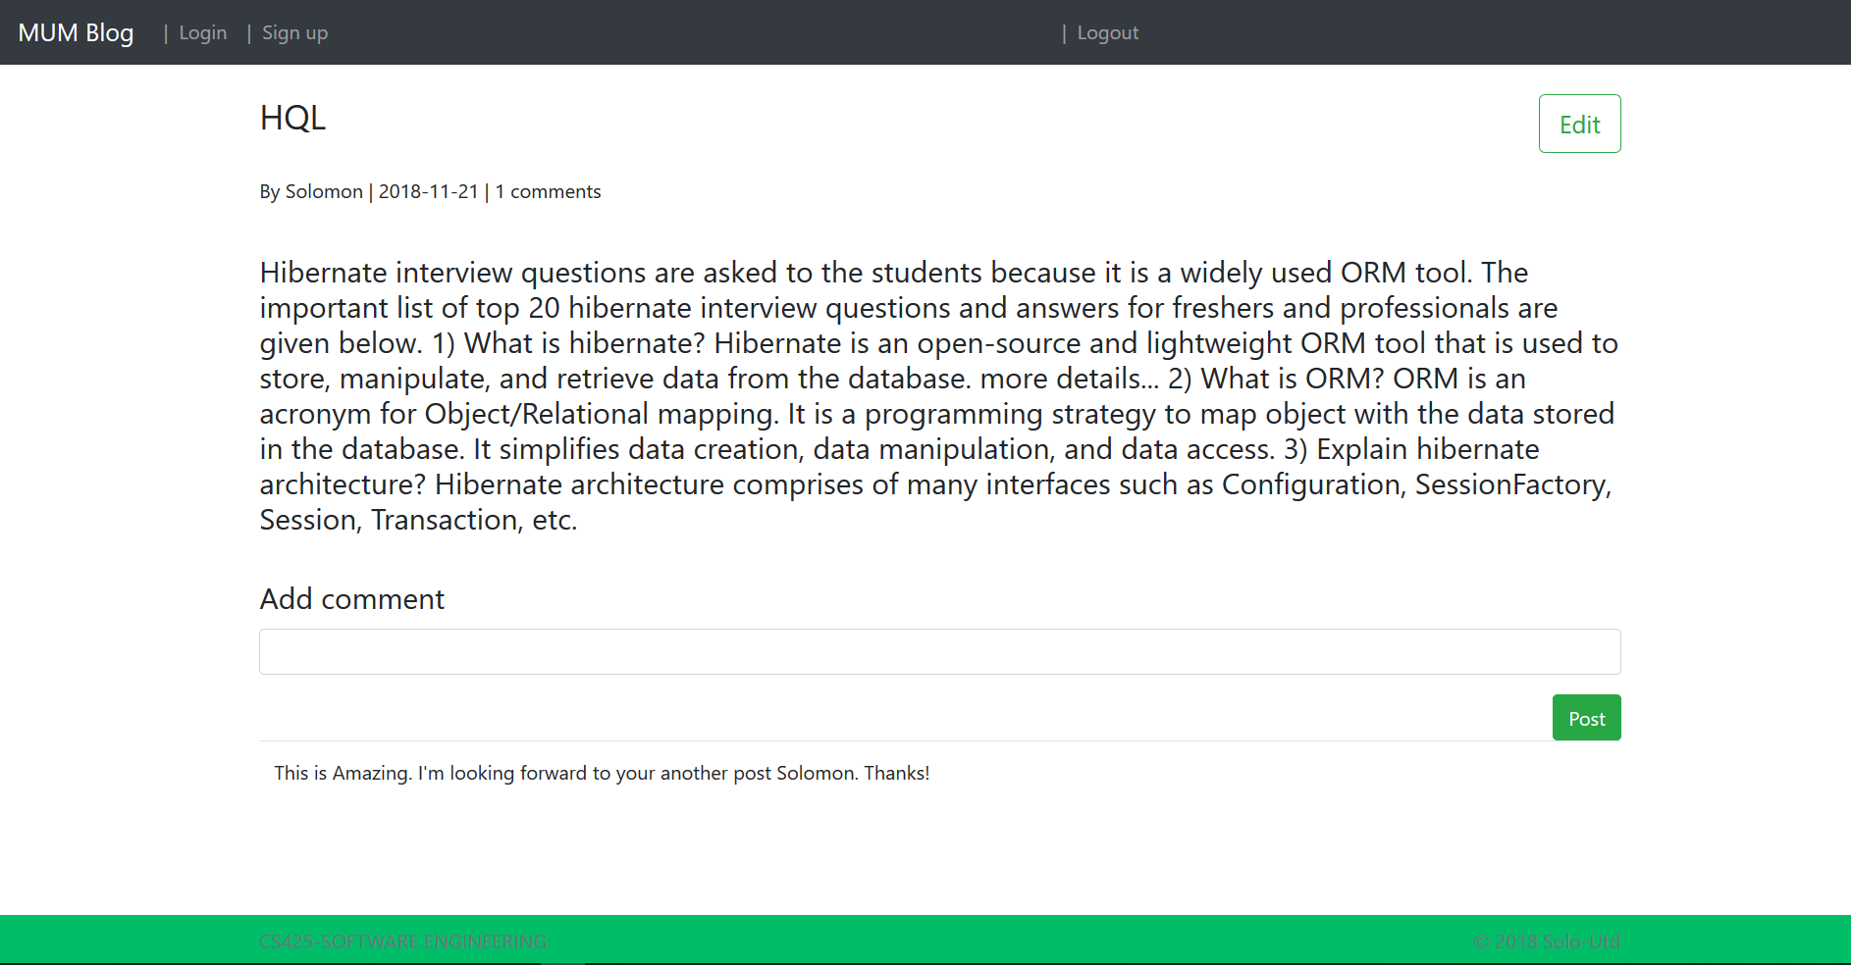

**CHAPTER 5**

**🡪 SYSTEM DESIGN**

**A screenshot of a cell phone

Description generated with high confidence**

**CHAPTER 6**

**Technologies:**

* **Spring Boot  
  basically this Web Application is designed implemented using Spring Framework. Specifically, Spring Boot.**
* **Thymeleaf  
  is used for the front end**
* **Bootstrap   
  used for front end user interfaces**
* **Hibernate  
  used to persist and access database**
* **MYSQL  
  used to store data   
    
  Materials:**
* **Intelliji  
  I used intelliji for the developing the project**
* **POSTMAN  
  used for fastening the Project development(Back-end)**
* **Visio  
  used for the drawing of all the User cases and User analysis**
* **Project Professional  
  used to trace my day to day tasks**
* **Github  
  used to store my code and share it to the world.**

**CHAPTER 7.**

Add New Article: for adding a new post after you sign in as a user.

Admin home: to view all the approved and pending posts after you sign in as admin.

Save: to save your post

Cancel: to Cancel whatever you were doing and back to the home page.

Signup: to register a new User.

Post: to post your comment to a single post.

Edit: edit a post. But only if you own that post.

Update: to save the change you made to a post after edit.

Login: to log yourself in as a USER OR ADMIN.

Log out: to log out from the System.

Approve: to approve a post as admin.

Delete: to Delete a post from the system as admin.

Pending posts: to check the post which are in pending process only as admin.